Calcareous Soils

Calcareous Soils: Calcareous soils are found in arid, semi-arid regions as well as in some humid regions and contain accumulations of lime (calcium carbonate,CaCO₃).They are the result of the weathering of a variety of rocks particularly calcite, and dolomite. The content of calcium and magnesium carbonates may vary from 10 to as high as 70% of the total soil mass. Calcium carbonate occurs in the sand, silt and clay-size fractions, and the proporation in each fraction varies greatly. Low rainfall in arid and semi-arid regions is not sufficient to leach out the soluble products of weathering to ground water. In dry weather, the main movement of soluble salts is upwards to the soil surface, through the capillary movement, where they are deposited.
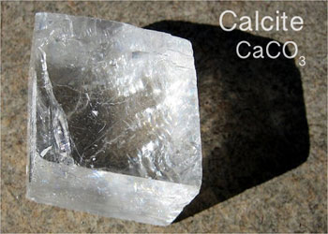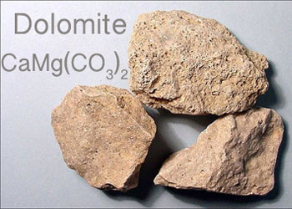
Calcareous soils are found in Egypt mainly along the northern coast and in Sinai Peninsula.
Characteristics of calcareous soils:
Physical and chemical properties of calcareous soils are unsuitable for plant growth. Calcareous soils are characterized by soil crusting i.e. formation of calcareous crust on the soil surface. Such crusts impede emergence of plant seedlings.
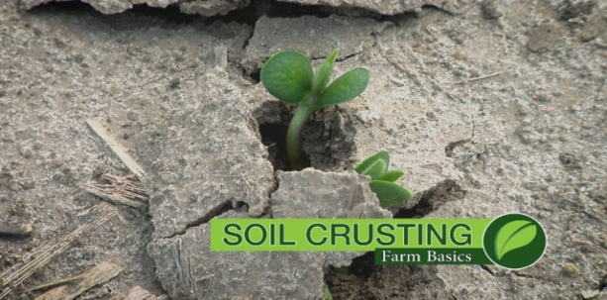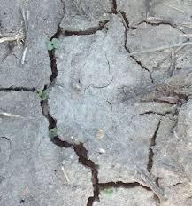
Calcareous soils are characterized by:
- Formation of crusts the thickness of which may be up to cm or more.
- Presence of calcium carbonates in different forms with or without magnesium carbonate.
- Presence of Ca ions (and Mg ions) adsorbed on soil colloids forming up to 90 % adsorbed bases.
- Effervescence when in contact with acids.
- High pH of up to 8.2 to 8.4.
- Low organic matter contents.
- Low plant nutrient contents (other than Ca and Mg) including P, K, Fe, Mn and Zn.
- The dominant clay minerals are the montmorellonite group and mineral of the expanding lattice .
- Calcareous soils remain in a flocculated condition and structure of the granulated types.
- Presence of cemented calcium carbonate hardpans, which hinder plant growth and movement of percolating water .The depth of these hardpans depends on the climatic conditions especially, the amount of rainfall.
Problems of calcareous soils
Problems of calcareous soils are mainly associated with, alkaline pH, free calcium and magnesium carbonate, reactions with plant nutrients, problems with plant roots and moisture.
Problems
I. Formation of soil crusts.
II. Alkaline pH.
III. Low fertility.
IV. Moisture characteristics.
I- Formation of soil crusts:
Causes:
Soil surface is covered with hard calcareous crust. The thickness varies from few millimeters to several centimeters. These crusts inhibit emergence of plant plumules germinating seed above the soil surface, thus preventing proper germination of crop seeds. Germination may be prevented or delayed altogether. Also, crusts decrease water percolation and decrease soil aeration.
Reclamation:
1- Interval between the successive irrigations should be relatively short to avoid the formation of calcareous crust on the soil surface.
2- Addition of organic matter increases the ability of soil to retain water and reduce crusting.
3- Avoiding excessive drying of soil. Moisture tension should not increase during seedling of 0.033 MPa (1air pressure= 0.1MPa).
4- Increasing the number of seeds per hill during seeding operation.
5- Avoiding deep seeding, the depth of seed placement should not exceed 4 cm.
6-Applying a light irrigation following seeding.
7- Crushing the surface crust: This is done by plowing in a certain direction and then plowing back in a vertical direction on the direction of the previous plowing at a depth of 25 cm and at a moisture of about 8%.
II- The alkaline pH.
- pH of the calcareous soils is usually ranging from 8.2 to 8.4.

Causes:
The pH of calcareous soils rises as water is increased. This is attributed to the hydrolysis of calcium carbonate resulting in an increase in hydroxyl ions as follows:
CaCo₃+H₂O Ca²⁺+ HCO₃⁻ + OH⁻

The OH– ions cause alkalinity, while the HCO₃– ions behave as a weak acid HCO₃– H⁺ + CO₃^{2-.} The pH of calcareous soils is usually above 7.0 and may be as high as 8.5. This variation is due to partial pressure of CO₂ being high and formation of un-dissociated carbonic acid. Thus hydrolysis of CaCO₃ is decreased.
The lowering of partial pressure of CO₂ on dilution of soil suspension increases the pH of the soil.
Reclamation:
Because of the above-mentioned reactions and relationships between moisture and pH, the control of excess water is important in calcareous soils. The build-up of OH⁻ ions formed by hydrolysis of CaCO₃ is prevented by adequate CO₂ in the soil. When sufficient amounts of farm yard manure, compost and green manure are added, the amount of carbon dioxide as well as the amount of acids increases and as a result the pH of soil decreases.

III- Low fertility
Causes:
Calcareous soils are low nutrient contents, due to the low organic matter content and high calcium carbonate content as well as the alkaline pH, which affects the availability of elements such as phosphorus, iron and manganese.
- Nitrogen
Low organic matter (the main source of nitrogen in the soil) indicates low nitrogen content in the soil. Nitrogen deficiency in calcareous soil is not the only problem related to this element, but the soil content of calcium carbonate and the alkaline pH have a negative effect on the extent of utilization of ammonium, ammonia, or added nitrogen fertilizers. Calcium carbonate interacts with ammonium fertilizers forming ammonium carbonate and bicarbonate, which decompose into carbon dioxide, water and ammonia. Loss of ammonia by volatilization means loss of nitrogen from the soil.
(NH₄)₂SO₄ + CaCO₃ (NH₄)₂Co₃ + Ca SO₄
(NH₄)₂CO₃ 2NH₃ + CO₂ + H₂O
Loss of up to 25% of added ammonium fertilizers may occur in soils containing as low as about 4% calcium carbonate. Losses may increase to as high as 42% in soils containing 23% calcium carbonate. Therefore, it is recommended to apply N in calcareous soils in the form of nitrate rather than ammonium.

- Phosphorus
In the presence of CaCO₃, soluble orthophosphate (main salt of soluble phosphate fertilizers) is converted into the di-calcium phosphate (which is sparingly soluble) then changes slowly into tricalcium phosphate “apatite” (which is insoluble). Soluble forms of phosphate can also be adsorbed and precipitate on surface of calcium carbonate particles. Soluble Ca and Mg ions and their carbonates in the soil tend to precipitate P and thus lower its availability. Such reactions leading to decreased solubility of P are referred to as P-fixation reactions, which incur soluble P fertilizers and cause a very low recovery of applied fertilizer P.
Ca (H₂PO₄)₂ + 2CaCO₃ Ca₃ (PO₄)₂+ 2CO₂ + 2H₂O

- Potassium
The content of the calcareous soils of potassium depends on their clay content as well as the type of predominant clay mineral. Plants grown in calcareous soils tend to suffer from K deficiency because excess calcium ions cause more Ca and less K to be absorbed by plants. Different forms of K in calcareous soil (water soluble, exchangeable and non-exchangeable K) correlate negatively with the CaCO₃ content.

- Iron
Plant leaves suffer from yellowing due to lack of iron in soils due to presence of lime. Such condition is referred to as Lime induced iron chlorosis. This yellowing is due to the failure of plants to absorb available iron due to the abundance of calcium carbonate, which precipitate iron in the form of ferric carbonate and iron hydroxide ( both of which are unavailable for plant). The reaction between carbonate ions and ferrous iron in calcareous soil under moist conditions is as follows:
Fe²⁺ + CaCO₃ FeCO₃ + Ca²⁺
4 FeCO₃ + Ca (HCO₃) ₂ + O₂ 2Fe₂ (CO₃) ₃ + Ca (OH) ₂
Fe₂ (CO₃) ₃ + 3H₂O Fe₂ O₃+ 3H₂ CO₃

- Zinc
Availability of zinc is reduced in calcareous soils. At any pH over 6 in calcareous soils, carbonates and other soil minerals adsorb Zn.
- Manganese
When Mn is added to calcareous soils under normal moisture conditions, Mn undergoes rapid oxidation and precipitates as hydrated Mn(OH)₂ or MnCO₃.

Proper management regarding nutrients:
- Application of organic matter manures is vital in reclamation of calcareous soils. They provide the soil with the necessary nutrients for soil fertility and plant nutrition, and increase the biological activity and number of soil micro-organisms. Decomposition of organic matter releases many functional groups, which increase the availability of nutrients in the soil. The amount of carbon dioxide and organic acids increases due to decomposition of organic matter. The CO₂ resulting from the activity of microorganisms reacts with water and form carbonic acid H₂CO₃ which reduce the soil pH, and increase the availability of most nutrients particularly the micronutrients.
- Application of sulphur which acidifies the soil upon its oxidation in the soil producing sulphuric acid.
- Proper management of P fertilization. Phosphate fertilizers should be placed near the roots of plant. Using granulated P-fertilizers (pelleted) is preferred to using pulverized (powdered). The former forms keeps fixation of P to minimum since it does not allow greater surface area of the P-fertilizer particles to be in contact with soil calcium carbonate. The use of powdered P-fertilizers on the other hand would cause increased fixation of phosphate fertilizers due to the high surface area of fertilizer particles.
- Addition of micronutrients like, zinc, copper, iron would be helpful in increasing the yield. The addition of micro elements is preferred as a foliar application to avoid the effect of the reaction with calcium carbonate in the soil as well as the soil pH.
- Lime induced iron chlorosis can be controlled by direct application of suitable ion chelates such as EDTA and EDDHA. These chelates must be stable in calcareous soils and not to be converted to calcium chelates and they must not easily decomposable by the soil organisms.

IV. Moisture characteristics
Moisture in calcareous soils must be managed properly to avoid formation of crusts .Water is spread rapidly due to the presence of calcium carbonate, which affect on aggregation .Secondary salinity is widespread in these soils because of the speed of water movement and its infilteration from the soil and channels which is adjacent to nearby areas.
Proper management regarding moisture
Moisture properties and soil water relations should be controlled and the following recommendations should be concsidered:
- Avoiding over irrigtion to prevent the hydrolysis of CaCO₃ which increasing the pH.
- Intervals between the successive irrigations should be relatively short to avoid the formation of calcareous crust .
- Presence of an efficient drainage system and destruction of hardpans by deep plowing.
- Irrigation channels should be coated with clay or cement to prevent secondary salination.
- Sandy calcareous soils develop large pores due to low water-holding capacity. Therefore, such soils need compaction by plank or roller to increase their water- holding capacity.

"The potential productivity of calcareous soils is high where adequate water and nutrients can be supplied. The high calcium saturation tends to keep the calcareous soils in well aggregated form and good physical condition".

Suitable crops for cultivation in calcareous soil
Most crops grow well in calcareous soils and the surrounding climatic conditions have the greatest impact on the success of one crop.Crops suitable for planting in such soils of the northwestern coast of Egypt are wheat, barley, tomatoes, olives and figs. In the Burj al-Arab region, olives, figs, almonds, cherubs, grapes, and plums are planted.Alfalfa and vegetables such as tomatoes, peppers, zucchini and melons are among crops suitable for such soils.
Projects of reclamation of calcareous soils in Egypt
- The northern sector of El-Tahrir region (45thousand feddans – about 19 thousand ha).
- Maruit sector (80 thousand feddans – about 34 thousand ha).
- The northwestern coastal area of the plain extends along the Mediterranean coast, west of the city of Alexandria with an area of (60 thousand feddans – about 25 thousand ha).

